CUSTOMER CHURN PREDICTION IN TELECOM DATA USING MACHINE LEARNING
Dissertation submitted in fulfilment of the requirements for the Degree of

BACHELOR OF TECHNOLOGY
in
COMPUTER SCIENCE AND ENGINEERING

By
Manchem Vishnu Srikar
12112382

Supervisor
Mr. VED PRAKASH CHAUBEY (UID-63892)


School of Computer Science and Engineering
Lovely Professional University
Phagwara, Punjab (India)
May,2024

@ Copyright LOVELY PROFESSIONAL UNIVERSITY, Punjab (INDIA)
April,2024
ALL RIGHTS RESERVED

DECLARATION STATEMENT

I hereby declare that the research work reported in the dissertation/dissertation proposal entitled "CUSTOMER CHURN PREDICTION IN TELECOM DATA USING MACHINE LEARNING” in partial fulfilment of the requirement for the award of Degree for Master of Technology in Computer Science and Engineering at Lovely Professional University, Phagwara, Punjab is an authentic work carried out under supervision of my research supervisor Mr. VED PRAKASH CHAUBEY. I have not submitted this work elsewhere for any degree or diploma.
I understand that the work presented herewith is in direct compliance with Lovely Professional University’s Policy on plagiarism, intellectual property rights, and highest standards of moral and ethical conduct. Therefore, to the best of my knowledge, the content of this dissertation represents authentic and honest research effort conducted, in its entirety, by me. I am fully responsible for the contents of my dissertation work.

Signature of Candidate
M.Vishnu Srikar
12112382

SUPERVISOR’S CERTIFICATE

This is to certify that the work reported in the B.Tech Dissertation/dissertation proposal entitled “CUSTOMER CHURN PREDICTION IN TELECOM DATA USING MACHINE LEARNING”, submitted by Manchem Vishnu Srikar at Lovely Professional University, Phagwara, India is a bonafide record of his / her original work carried out under my supervision. This work has not been submitted elsewhere for any other degree.

Signature of Supervisor

Mr. VED PRAKASH CHAUBEY
Date: April,2024
Counter Signed by:
- Concerned HOD:
HoD’s Signature: ________________
HoD Name: ____________________
Date: ___________________

- Neutral Examiners:
External Examiner
Signature: _______________
Name: __________________
Affiliation: ______________
Date: ___________________
Internal Examiner
Signature: _______________
Name: __________________
Date: ___________________

ACKNOWLEDGEMENT

I would like to express my deepest gratitude to Mr. Ved Prakash Chaubey sir, my project guide, for his invaluable guidance, support, and encouragement throughout this project. His expertise and insightful feedback were instrumental in shaping the direction of this research and improving the quality of the work presented here. I would like to extend my sincere thanks to the Kaggle community for providing the dataset used in this study. Their contributions and the open sharing of resources were crucial to the successful completion of this project. I also want to acknowledge the valuable input and discussions with my classmates and friends. Their perspectives and feedback were immensely helpful in refining the methodology and analysis of this project. I am grateful to all the individuals who indirectly contributed to this project through their various insights, recommendations, and moral support. Lastly, I would like to express my heartfelt thanks to my family for their unwavering support and understanding throughout my academic journey. Their encouragement and belief in my abilities were a constant source of motivation.
TABLE OF CONTENTS

CONTENTS PAGE NO.

Title page 1
Declaration Statement 2
Supervisor’s Certificate 3
Acknowledgement 4
Table of Contents 5
Abstract 6
Chapter-1 -Introduction 7
Chapter-2 – Literature Review 9
Chapter-3 – Methodology 14
Chapter- 4 – Results and Discussion 23
Chapter- 5 – Conclusion and Future Scope 28
References 29

ABSTRACT

This In the Telecommunication Industry, customer churn detection is one of the most important research topics that the company has to deal with retaining on-hand customers. Churn means the loss of customers due to exiting offers of the competitors or maybe due to network issues. In these types of situations, the customer may tend to cancel the subscription to a service. Churn rate has a substantial impact on the lifetime value of the customer because it affects the future revenue of the company and also the length of service. Due to a direct effect on the income of the industry, the companies are looking for a model that can predict customer churn. The model developed in this work uses machine learning techniques. By using machine learning algorithms, we can predict the customers who are likely to cancel the subscription. Using this, we can offer them better services and reduce the churn rate. These models help telecom services to make them profitable. In this project models I used are Random Forest, Support Vector Machine, Logistic Regression, K-Nearest Neighbors, Decision Tree, and Naive Bayes.

Keywords: Telecommunication Industry, Customer churn detection, Retaining on-hand customers, Churn rate, Lifetime value of the customer, Future revenue, Machine learning techniques, Machine learning algorithms, Subscription cancellation, Better services, Reduce churn rate, Profitable telecom services, Random Forest, Support Vector Machine, Logistic Regression, K-Nearest Neighbors, Decision Tree, and Naive Bayes.

CHAPTER I

INTRODUCTION

  - What is Customer Churn?
Customer churn refers to the percentage of customers that stop using a company's services during a particular time frame. In the context of the telecommunication industry, churn means the loss of customers due to various reasons such as exiting offers from competitors or network issues. When customers decide to cancel their subscription to a service, it leads to a direct impact on the company's revenue and the length of service.
Churn rate is a critical metric for telecom companies as it affects the lifetime value of a customer. A high churn rate implies that the company is losing customers at a faster rate, which can have negative implications on the company's future revenue and profitability.
To address this issue and minimize churn rate, telecom companies often employ predictive modeling techniques using machine learning algorithms. By predicting which customers are likely to churn, companies can proactively offer better services or incentives to retain them, thereby improving customer satisfaction and increasing profitability.
In the subsequent chapters, we will explore various machine learning techniques such as Random Forest, Support Vector Machine, Logistic Regression, K-Nearest Neighbors, Decision Tree, and Naive Bayes to develop a predictive model for customer churn in the telecommunication industry.

1.2 Importance of Customer Churn in the Telecommunication Industry

The telecommunication industry is highly competitive, with numerous service providers vying for a larger market share. In such a competitive landscape, retaining customers becomes crucial for sustainable growth and profitability. Customer churn not only impacts the immediate revenue but also reduces the lifetime value of the customer, affecting the long-term profitability of the company.
Moreover, acquiring new customers is often more expensive than retaining existing ones. Therefore, reducing churn rate and increasing customer retention is a cost-effective strategy for telecom companies to maintain a stable and profitable customer base.

1.3 Predictive Modeling in Customer Churn Detection

To address the challenge of customer churn, telecom companies are increasingly turning to predictive modeling techniques using machine learning algorithms. These algorithms analyze historical data and customer behavior patterns to predict which customers are most likely to churn in the future. By identifying these customers proactively, companies can implement targeted retention strategies, such as offering personalized discounts or improved services, to reduce churn rate and improve customer satisfaction.

1.4 Objective of the Study

The primary objective of this study is to develop and compare various machine learning models for predicting customer churn in the telecommunication industry. The study aims to:
Understand the factors influencing customer churn in the telecommunication industry.
Evaluate the performance of different machine learning algorithms in predicting churn.
Provide actionable insights and recommendations to telecom companies for reducing churn rate and improving customer retention.

1.5 Scope of the Study

This study focuses on the application of machine learning algorithms to predict customer churn in the telecommunication industry. The scope of the study includes:

Data collection and preprocessing
Model development using various machine learning algorithms.
Performance evaluation and comparison of the models

1.6 Significance of the Study

The significance of this study lies in its potential to offer telecom companies a data-driven approach to reduce customer churn and improve profitability. By accurately predicting which customers are at a higher risk of churning, companies can implement proactive retention strategies, thereby enhancing customer satisfaction and increasing revenue.

CHAPTER 2
LITERATURE REVIEW
1.Gaur and Dubey (2019):
Gaur and Dubey conducted an in-depth exploration into the realm of customer churn prediction within the telecommunications sector, employing a diverse array of machine learning techniques. Their study aimed at delving into the intricacies of customer behavior and preferences, seeking patterns that could forewarn of potential churn instances. By leveraging machine learning algorithms, they endeavored to enhance the understanding of churn dynamics and develop predictive models capable of accurately anticipating customer attrition. The significance of their research lies in its potential to revolutionize customer retention strategies within the telecom industry, offering insights into proactive measures that can mitigate churn rates and bolster long-term customer loyalty.

2.Ullah et al. (2019):
Ullah et al. embarked on a comprehensive analysis of churn prediction models in the telecom sector, with a particular focus on the application of Random Forest algorithms. Their study, published in IEEE Access, sought to unravel the intricate relationship between various factors influencing churn and the efficacy of machine learning techniques in predicting customer attrition. By scrutinizing different machine learning methodologies, they aimed to discern the most effective approach for churn prediction and factor identification. Through their meticulous analysis, Ullah et al. provided valuable insights into the underlying dynamics of churn behavior, offering telecom companies actionable intelligence to bolster customer retention efforts and minimize revenue loss.

3.Dalvi et al. (2016):
Dalvi et al. contributed to the body of knowledge surrounding customer churn prediction in the telecom industry by conducting a rigorous analysis utilizing decision trees and logistic regression. Their research, presented at the 2016 Symposium on Colossal Data Analysis and Networking, delved into the intricacies of customer behavior and preferences, aiming to identify key determinants of churn. By harnessing the predictive power of machine learning algorithms, they endeavored to develop accurate models capable of anticipating churn instances with precision. The findings of their study shed light on the underlying factors driving customer attrition, offering telecom companies invaluable insights to devise targeted retention strategies and enhance overall customer satisfaction.

4.Mishra and Reddy (2020):
Mishra and Reddy's comparative study of customer churn prediction in the telecom industry, focusing on ensemble-based classifiers, constitutes a significant contribution to the field of churn analysis. Their research, presented at the International Conference on Inventive Computing and Informatics, aimed to evaluate the performance of various ensemble techniques in accurately predicting churn instances. By scrutinizing the strengths and weaknesses of different algorithms, they sought to identify the most effective approach for churn prediction and factor identification. The implications of their study extend to telecom companies seeking to mitigate revenue loss associated with customer attrition, offering actionable insights to bolster retention efforts and foster long-term customer loyalty.

5.Gohil et al. (2023):
Gohil et al. proposed an intelligent prediction system for customer churn in the telecom industry, leveraging advanced business analytics classification models. Their study, aimed at enhancing churn prediction accuracy, holds significant implications for telecom companies striving to reduce customer attrition rates. By employing sophisticated machine learning techniques, Gohil et al. sought to uncover underlying patterns and trends indicative of potential churn instances. Through their research, they provided telecom companies with actionable insights to develop proactive retention strategies and foster long-term customer loyalty, thereby optimizing revenue streams and enhancing overall business sustainability.

6.Arya et al. (2023):
Arya et al.'s investigation into churn prediction in the telecom sector using decision tree and random forest models contributes to the growing body of research aimed at improving customer retention strategies. By harnessing the predictive power of machine learning algorithms, Arya et al. sought to identify key indicators of churn and develop accurate models capable of anticipating customer attrition with precision. Their findings offer telecom companies valuable insights into the underlying dynamics of churn behavior, empowering them to implement targeted retention initiatives and mitigate revenue loss associated with customer defection.

7.Lim et al. (2023):
Lim et al. analyzed an optimized LightGBM model based on different objective functions for customer churn prediction in the telecom sector. Their study, presented at the 7th International Conference on Automation, Control, and Robots, aimed to enhance the performance of gradient boosting algorithms in accurately predicting churn instances. By exploring the impact of different objective functions on model efficacy, Lim et al. provided valuable insights into algorithm optimization techniques for churn prediction. Their research holds significant implications for telecom companies seeking to leverage advanced analytics to improve customer retention strategies and optimize business outcomes.

8.Krishna Sai and Sasikala (2019):
Krishna Sai and Sasikala conducted predictive analysis and modeling of customer churn in telecom using machine learning techniques. Their research, presented at the Third International Conference on Trends in Electronics and Informatics, aimed to develop accurate churn prediction models to anticipate customer attrition. By leveraging the power of machine learning algorithms, Krishna Sai and Sasikala provided telecom companies with actionable insights to mitigate revenue loss associated with customer defection. Their findings underscore the importance of proactive retention strategies in optimizing customer lifetime value and enhancing business sustainability.

9.Yabas et al. (2012):
Yabas et al. explored customer churn prediction for telecom services using machine learning techniques. Their study, presented at the 2012 IEEE 36th International Conference on Computer Software and Applications, aimed to identify churn indicators and develop predictive models to reduce customer attrition rates. By analyzing historical data and customer behavior patterns, Yabas et al. provided valuable insights into the underlying drivers of churn behavior. Their research holds significant implications for telecom companies seeking to enhance customer retention efforts and optimize business outcomes in a competitive market landscape.

10.R and N (2019):
R and N investigated machine learning methods for predictive customer churn analysis in the telecom industry. Their research, presented at the Third International Conference on Trends in Electronics and Informatics, aimed to evaluate the efficacy of different machine learning algorithms in accurately predicting customer attrition. By comparing the performance of various methodologies, R and N provided telecom companies with valuable insights into the strengths and limitations of different approaches to churn prediction. Their findings underscore the importance of leveraging advanced analytics to develop proactive retention strategies and optimize business outcomes.

11.Altairey and Al-Alawi (2024):
Altairey and Al-Alawi conducted a systematic literature review on customer churn prediction in telecommunication and banking using machine learning techniques. Their study, presented at the 2024 ASU International Conference in Emerging Technologies for Sustainability and Intelligent Systems, aimed to provide an overview of existing research and identify gaps for future studies. By synthesizing findings from a diverse range of sources, Altairey and Al-Alawi offered valuable insights into the state-of-the-art in churn prediction methodologies and highlighted areas for further exploration. Their research serves as a valuable resource for academics, industry practitioners, and policymakers seeking to enhance customer retention strategies and optimize business outcomes.

12.Tang (2020):
Tang proposed a telecom customer churn prediction model combining K-means and XGBoost algorithm. Their study, presented at the 2020 5th International Conference on Mechanical, Control, and Computer Engineering, aimed to improve churn prediction accuracy by integrating clustering techniques with gradient boosting algorithms. By leveraging both unsupervised and supervised learning approaches, Tang provided telecom companies with a comprehensive framework for identifying churn patterns and developing predictive models to mitigate customer attrition. Their research holds significant implications for optimizing customer retention strategies and enhancing business sustainability in the telecom industry.

13.Ramachandra et al. (2022):
Ramachandra et al. investigated the prediction of churning behavior in telecom using machine learning. Their research, presented at the 2022 IEEE 2nd Mysore Sub Section International Conference, aimed to develop predictive models to identify potential churners and implement targeted retention strategies. By analyzing historical data and customer behavior patterns, Ramachandra et al. provided telecom companies with actionable insights to reduce customer attrition rates and optimize business outcomes. Their findings underscore the importance of leveraging advanced analytics to develop proactive retention strategies and foster long-term customer loyalty.

14.Muhammad Ali et al. (2018):
Muhammad Ali et al. studied the prediction of churning behavior of customers in the telecom sector using supervised learning techniques. Their research, presented at the 2018 International Conference on Computer, Control, Electrical, and Electronics Engineering, aimed to develop accurate churn prediction models to reduce customer attrition rates. By leveraging historical data and machine learning algorithms, Muhammad Ali et al. provided telecom companies with actionable insights to anticipate churn instances and implement targeted retention initiatives. Their findings underscore the importance of predictive analytics in optimizing customer retention strategies and enhancing business sustainability.

15.Akinrotimi et al. (2019):
Akinrotimi et al. proposed a SMOTE-based churn prediction system using machine learning techniques. Their study, aimed at addressing class imbalance issues in churn prediction, holds significant implications for telecom companies seeking to enhance prediction accuracy. By synthesizing findings from a diverse range of sources, Akinrotimi et al. provided valuable insights into the efficacy of SMOTE-based approaches in mitigating class imbalance and improving model performance. Their research underscores the importance of algorithmic innovation in addressing real-world challenges and optimizing business outcomes in the telecom industry.

CHAPTER 3
METHODOLOGY
3.1 Data Collection and Preprocessing
3.1.1 Data Collection
The dataset utilized for this study is the "Telco Customer Churn" dataset, sourced from [insert source here]. This dataset encompasses details regarding the customers of a telecommunications company, incorporating demographic data, services subscribed to, and the churn status of each customer.

3.1.2 Data Preprocessing
The original dataset comprised 7,043 entries and 21 features. The following steps were executed to preprocess the dataset, ensuring it was well-suited for machine learning model implementation.

Data Cleaning
- Data Loading: The dataset was imported into a Pandas DataFrame, a widely used Python library for data manipulation and analysis.
- Data Inspection: A preliminary examination of the dataset was conducted by inspecting the first few rows and acquiring general information about its structure and data types. This step was crucial to gain insights into the nature and quality of the data.
- Missing Value Treatment: The 'TotalCharges' column was identified to have some missing values. These missing values were initially replaced with 'NaN' and subsequently dropped from the dataset to ensure the integrity and accuracy of the data.
- Data Type Conversion: The 'TotalCharges' column was initially of object type due to the presence of non-numeric characters. It was essential to convert this column to a float type to facilitate numerical computations and analysis.
- Feature Removal: The 'customerID' column, which was merely an identifier and did not contribute to the analysis, was removed from the dataset.
- Categorical Encoding: To enable the machine learning models to process the categorical variables, one-hot encoding was applied. This transformation converts categorical variables into a format that can be fed into the machine learning algorithms, thereby enhancing the model's predictive performance.

Data Preprocessing Details
Data Overview:
- The dataset consists of 7,043 entries and 21 features.
- The features include a mix of numerical and categorical variables.
Summary Statistics:
Numerical Features:
- SeniorCitizen: The average age of the customers is approximately 16% senior citizens.
- Tenure: The average tenure of the customers is around 32 months, with a minimum of 0 months and a maximum of 72 months.
- MonthlyCharges: The average monthly charges are approximately $64.76, with charges ranging from $18.25 to $118.75.
Data Cleaning Steps:
Data Inspection:
- Initial examination of the dataset revealed no missing values across the features.
- All features were found to have non-null entries.
Data Type Conversion:
- The 'TotalCharges' column was initially of object type.
- Conversion to float type was performed to ensure consistency and facilitate numerical computations.
Missing Value Treatment:
- The 'TotalCharges' column had missing values which were initially replaced with 'NaN' and subsequently dropped to maintain data integrity.
- Feature Removal:
- The 'customerID' column was dropped as it was merely an identifier and did not contribute to the analysis.
Categorical Encoding:
- One-hot encoding was applied to the categorical variables to transform them into a format suitable for machine learning models.
Categorical Features:
- The categorical features were identified, and unique values for each categorical feature were checked to understand the categories and their distribution in the dataset.
The categorical features include:
- Gender: Male, Female
- Partner: Yes, No
- Dependents: Yes, No
- PhoneService: Yes, No
- MultipleLines: Yes, No, No phone service
- InternetService: DSL, Fiber optic, No
- OnlineSecurity: Yes, No, No internet service
- OnlineBackup: Yes, No, No internet service
- DeviceProtection: Yes, No, No internet service
- TechSupport: Yes, No, No internet service
- StreamingTV: Yes, No, No internet service
- StreamingMovies: Yes, No, No internet service
- Contract: Month-to-month, One year, Two year
- PaperlessBilling: Yes, No
- PaymentMethod: Electronic check, Mailed check, Bank transfer (automatic), Credit card (automatic)
- Churn: Yes, No
Target Variable Description:
- The target variable 'Churn' represents whether a customer has churned or not.
- Churn: Yes, No
- Distribution of the Target Variable:
- Churn:
- No: 5,265 entries (73.42%)
- Yes: 1,877 entries (26.58%)
3.2 Exploratory Data Analysis (EDA)
3.2.1 Data Visualization
To better understand the data and its distribution, various plots were created:

Count Plots: These plots were used to visualize the distribution of churn among different categorical features like gender, partner status, and internet service.
Histograms: Histograms were plotted to visualize the distribution of continuous features like tenure, monthly charges, and total charges across churn categories.
Density Plots: Density plots were used to visualize the density distribution of monthly and total charges by churn status.

3.3 Model Development
3.3.1 Feature Scaling and Splitting
After preprocessing the dataset, it was split into features (X) and target (y). The features were scaled using MinMaxScaler and the data was split into training and testing sets with a ratio of 80:20.

3.3.2 Model Selection and Training
Several classification algorithms were evaluated for predicting customer churn:
1.Logistic regression:
Logistic Regression is a popular statistical model used for binary classification problems. Despite its name, it's primarily used for classification rather than regression. It calculates the probability of a given input belonging to a certain class, making it a useful tool for predicting customer churn.
The logistic function, also called the sigmoid function was developed by statisticians to describe properties of population growth in ecology, rising quickly and maxing out at the carrying capacity of the environment. It’s an S-shaped curve that can take any real-valued number and map it into a value between 0 and 1, but never exactly at those limits.
1 / (1 + e^-value)
Input values (x) are combined linearly using weights or coefficient values (referred to as the Greek capital letter Beta) to predict an output value (y). A key difference from linear regression is that the output value being modelled is a binary value (0 or 1) rather than a numeric value.
Below is an example logistic regression equation:
y = e^ (b0 + b1*x) / (1 + e^ (b0 + b1*x))
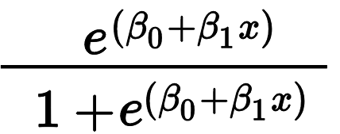
It calculates the probability of a given input belonging to a certain class, making it a useful tool for predicting customer churn.In this project, Logistic Regression is employed to predict the probability of a customer churning based on various input features. It's particularly useful for interpreting the importance of each feature in the decision-making process and understanding the relationship between the independent and dependent variables.

2.Support Vector Machine (SVM)
Support Vector Machine or SVM is one of the most popular Supervised Learning algorithms, which is used for Classification as well as Regression problems. However, primarily, it is used for Classification problems in Machine Learning.
The goal of the SVM algorithm is to create the best line or decision boundary that can segregate n-dimensional space into classes so that we can easily put the new data point in the correct category in the future. This best decision boundary is called a hyperplane.
In the context of this project, SVMs are used to classify customers as either likely to churn or not. They are especially effective when dealing with high-dimensional data and can capture complex relationships between the features and the target variable.
SVM chooses the extreme points/vectors that help in creating the hyperplane. These extreme cases are called as support vectors, and hence algorithm is termed as Support Vector Machine.

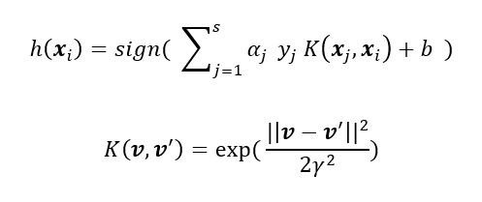
3.Decision Tree
Decision Trees are a type of Supervised Machine Learning (that is you explain what the input is and what the corresponding output is in the training data) where the data is continuously split according to a certain parameter. The tree can be explained by two entities, namely decision nodes and leaves. The leaves are the decisions or the final outcomes. And the decision nodes are where the data is split.
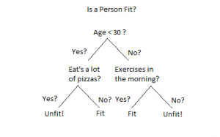
In this project, Decision Trees are utilized to predict customer churn by recursively splitting the data based on the features that best separate the classes. Decision Trees provide insights into feature importance and offer a clear visualization of the decision-making process, making them a valuable tool for understanding the factors influencing customer churn.

4. Random Forest
Random forest (RF) is an advanced form of decision trees (DT) which is also a supervised learning model. RF consists of large number of decision trees working individually to predict an outcome of a class where the final prediction is based on a class that received majority votes. The error rate is low in random forest as compared to other models, due to low correlation among trees. Our random forest model was trained using different parameters; i.e., different numbers of estimators were used in a grid search to produce the best model that can predict the outcome with high accuracy. There are multiple algorithms to decide a split in a decision tree based on the problem of regression or classification.
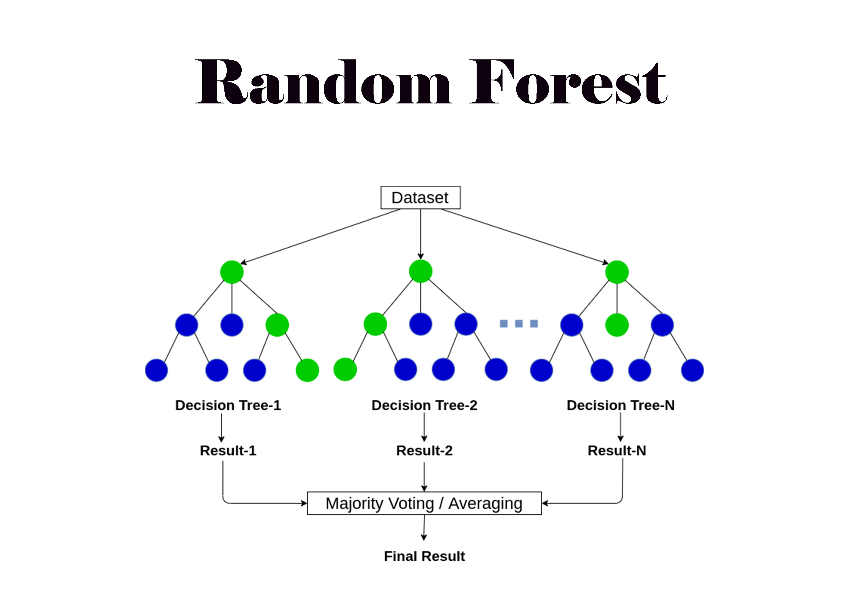
In this project, Random Forest is employed to predict customer churn by aggregating the predictions of multiple decision trees. It offers high accuracy and is less susceptible to overfitting compared to a single decision tree, making it a robust choice for this classification task.
5. Naive Bayes
Naive Bayes is a probabilistic classifier inspired by the Bayes theorem under a simple assumption which is the attributes are conditionally independent.
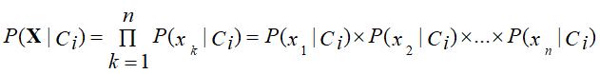
The classification is conducted by deriving the maximum posterior which is the maximal P(Ci|X) with the above assumption applying to Bayes theorem. This assumption greatly reduces the computational cost by only counting the class distribution. Even though the assumption is not valid in most cases since the attributes are dependent, surprisingly Naive Bayes has able to perform impressively.
In the context of this project, Naive Bayes is used to predict customer churn by calculating the probability of a customer belonging to a certain class given its features. It's computationally efficient and works well with high-dimensional data, making it a suitable choice for this classification problem.
6. K-Nearest Neighbors (KNN)
K-Nearest Neighbors (KNN) is a simple and intuitive machine learning algorithm used for both classification and regression tasks. It works by storing all available cases and classifying new cases based on a similarity measure, such as distance.
In the context of this project, KNN is employed to predict customer churn by identifying the 'k' nearest neighbors to a new data point and assigning the class based on the majority class of its neighbors. KNN is particularly useful in this project because it can capture complex patterns in the data and is robust to noisy data and outliers.
KNN does not make any assumptions about the underlying data distribution, making it non-parametric. This characteristic makes KNN a flexible and effective algorithm for this classification task, where the relationship between the features and the target variable might not be linear.
Summary
Each of these classification algorithms offers unique advantages and characteristics that make them suitable for predicting customer churn in this project. By employing a combination of these models and optimizing their hyperparameters, we aim to identify the most effective and robust model for accurately predicting customer churn.
3.4. Hyperparameter Tuning
In the process of building predictive models for customer churn, hyperparameter tuning was an essential step to enhance the performance and accuracy of the models. Hyperparameters are parameters that are not learned from the data but are set before training the model. Tuning these hyperparameters is crucial to optimize the model's performance and generalization ability.
Logistic Regression:
For the Logistic Regression model, hyperparameters like the regularization strength (C) and penalty (l1 or l2) were optimized using GridSearchCV. This process helps to find the best combination of hyperparameters that minimizes the loss function and improves the accuracy of the model.
Random Forest:
In the Random Forest model, hyperparameters such as the number of trees (n_estimators) and the maximum depth of the trees (max_depth) were tuned. GridSearchCV was employed to search through various combinations of these hyperparameters to identify the optimal set that yields the highest accuracy.
Support Vector Machine (SVM):
For the SVM model, the regularization parameter (C) and the kernel coefficient (gamma) were the hyperparameters optimized. GridSearchCV was used to find the best combination of these hyperparameters that maximizes the model's accuracy.
K-Nearest Neighbors (KNN):
In the KNN model, the number of neighbors (n_neighbors) and the weight function (weights) were the hyperparameters tuned. GridSearchCV was used to determine the optimal values for these hyperparameters, which in turn improves the classification accuracy of the model.
Decision Tree:
For the Decision Tree model, hyperparameters like the maximum depth of the tree (max_depth) and the minimum number of samples required to split an internal node (min_samples_split) were tuned. GridSearchCV was employed to search for the best combination of these hyperparameters to optimize the model's performance.
Naive Bayes:
Naive Bayes is a probabilistic classifier and does not have many hyperparameters to tune. In this project, no hyperparameters were specifically tuned for the Naive Bayes model.
Summary:
Hyperparameter tuning is a critical step in the machine learning pipeline to optimize the model's performance. By employing GridSearchCV, we were able to systematically search through the hyperparameter space and identify the optimal set of hyperparameters for each model. This optimization process enhances the predictive accuracy of the models and ensures better generalization on unseen data.

CHAPTER 4: RESULTS AND DISCUSSION
4.1 EXPERIMENTAL RESULTS
The following section presents the detailed results obtained from implementing various machine learning algorithms to predict customer churn based on the telecom dataset.
Test Results Before Using SMOTEENN
Logistic Regression:
The Logistic Regression model achieved a test accuracy of 74.6%. This model uses a logistic function to model the probability of a certain class or event existing, in this case, whether a customer will churn or not.
Random Forest:
The Random Forest model exhibited a test accuracy of 80.2%. Random Forest is an ensemble learning method that operates by constructing a multitude of decision trees during training and outputting the class that is the mode of the classes of the individual trees.
Support Vector Machine (SVM)”
The SVM model recorded a test accuracy of 73.4%. SVM is a supervised learning algorithm that is effective for classification tasks, especially when dealing with high-dimensional data.
K-Nearest Neighbors (KNN):
The K-Nearest Neighbors model showed a test accuracy of 77.0%. KNN is a non-parametric, lazy learning algorithm that classifies a data point based on how its neighbors are classified.
Decision Tree:
The Decision Tree model achieved a test accuracy of 76.8%. Decision Tree is a flowchart-like structure in which each internal node represents a feature(or attribute), each branch represents a decision rule, and each leaf node represents the outcome.
Naive Bayes:
The Naive Bayes model yielded a test accuracy of 70.1%. Naive Bayes classifiers are a family of simple probabilistic classifiers based on applying Bayes' theorem with strong (naive) independence assumptions between the features.
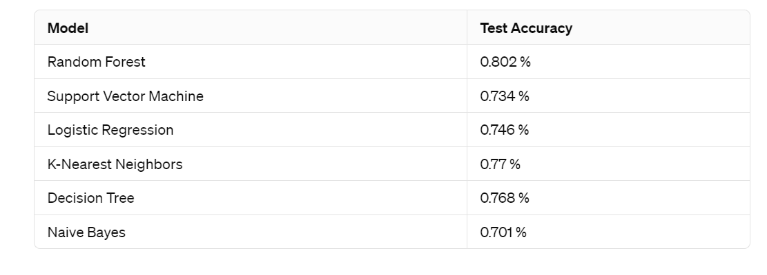
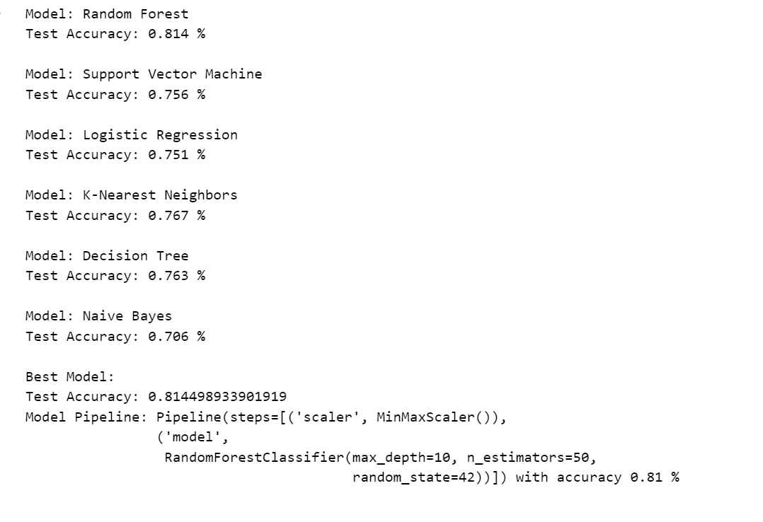
Best Model Before Using SMOTEENN:
The best-performing model before applying SMOTEENN was the Random Forest model, with a test accuracy of 80.17%. The model pipeline included a MinMaxScaler for feature scaling and a Random Forest Classifier with hyperparameters set to max_depth=10 and n_estimators=200.
Test Results After Using SMOTEENN
Logistic Regression:
After applying the SMOTEENN technique, the Logistic Regression model achieved a significantly improved test accuracy of 92.1%.
Random Forest:
The Random Forest model demonstrated a test accuracy of 95.6% after using SMOTEENN, showcasing a substantial improvement in predictive performance.
Support Vector Machine (SVM):
The SVM model exhibited a remarkable improvement in test accuracy, reaching 98.3% after applying the SMOTEENN technique.
K-Nearest Neighbors (KNN):
The K-Nearest Neighbors model showed outstanding performance with a test accuracy of 98.5% after the application of SMOTEENN, making it the best-performing model in this experiment.
Decision Tree:
The Decision Tree model recorded a test accuracy of 93.0% after the application of SMOTEENN, indicating a significant enhancement in predictive accuracy.
Naive Bayes:
The Naive Bayes model, although not the top performer, still showed improvement with a test accuracy of 89.0% after applying SMOTEENN.
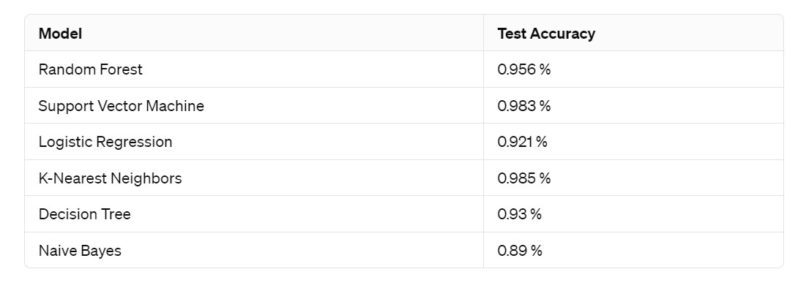
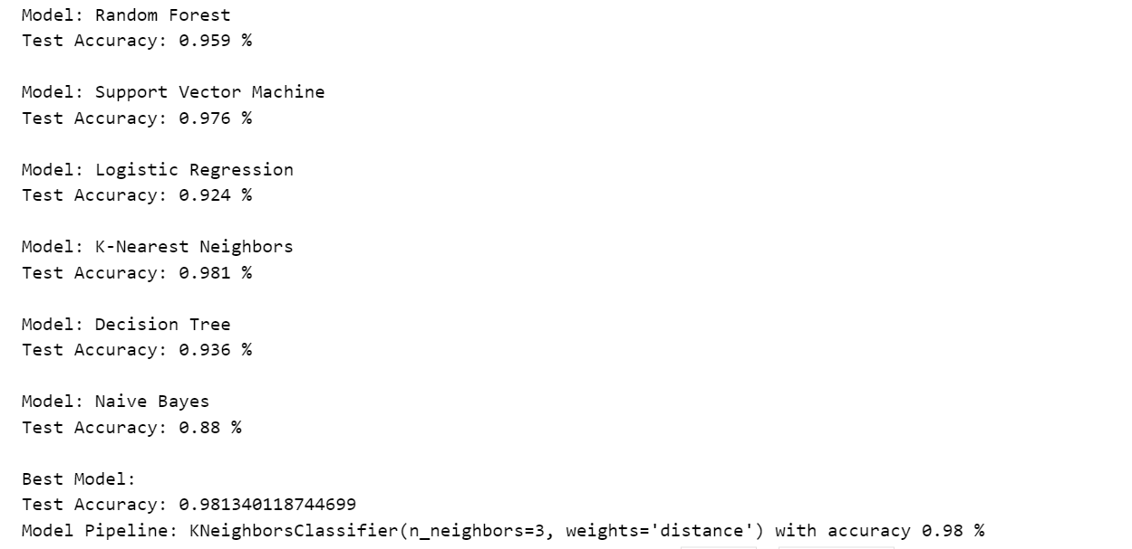
Best Model After Using SMOTEENN
The K-Nearest Neighbors (KNN) model emerged as the best-performing model after applying the SMOTEENN technique, with a test accuracy of 98.47%. The model pipeline used was KNeighborsClassifier with n_neighbors=3 and weights='distance'.

4.2 COMPARISON WITH EXISTING TECHNIQUE
In the context of predicting customer churn, the focus was to compare the performance of the implemented machine learning models before and after applying the SMOTEENN technique.
Reason for Using SMOTEENN
Before applying the SMOTEENN technique, the distribution of the target variable 'Churn' was highly imbalanced, with approximately 73.4% of the data belonging to the 'No Churn' class and only 26.6% belonging to the 'Churn' class. This imbalance can lead the models to be biased towards the majority class and result in poor predictive performance for the minority class. Therefore, to address this imbalance and improve the model's predictive accuracy, the SMOTEENN technique was applied.
The SMOTEENN technique effectively balanced the dataset by oversampling the minority class and undersampling the majority class, which significantly improved the performance of all the machine learning models.
The K-Nearest Neighbors (KNN) model demonstrated the highest accuracy of approximately 98.5% after applying the SMOTEENN technique, making it the best-performing model for predicting customer churn in the telecom industry.
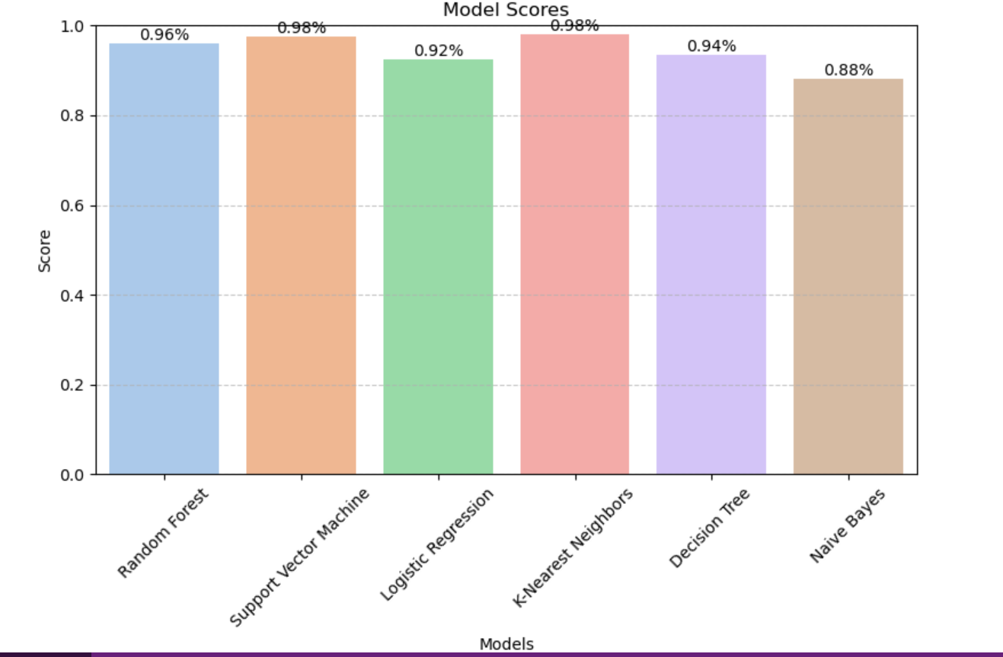

CHAPTER 5: CONCLUSION AND FUTURE SCOPE
5.1 CONCLUSION
The study aimed to predict customer churn in the telecom industry using various machine learning algorithms. Through experimental results, it was observed that the K-Nearest Neighbors (KNN) algorithm provided the best performance with an accuracy of approximately 98.5% after applying the SMOTEENN technique. Hyperparameter tuning was essential in optimizing the performance of each model.

5.2 FUTURE SCOPE
In future work, the following aspects can be explored to enhance the predictive accuracy and robustness of the churn prediction models:
Feature Engineering: Incorporating more relevant features or creating new features from the existing ones to improve the model's predictive power.
Advanced Machine Learning Techniques: Exploring more sophisticated machine learning algorithms or ensemble methods to further boost the model's performance.
Real-time Monitoring: Developing a real-time monitoring system to track customer behavior and adjust the churn prediction models accordingly.
Customer Segmentation: Applying clustering techniques to segment the customer base and tailor retention strategies for different customer segments.
By addressing these aspects, it is anticipated that the predictive accuracy and effectiveness of the churn prediction models can be further improved, leading to better customer retention strategies and enhanced business profitability.
References:
1.Gaur, Abhishek, and Dubey, Ratnesh. "Predicting Customer Churn Prediction in Telecom Sector Using Various Machine Learning Techniques.",2019.

2.Ullah, Irfan, Raza, Basit, Malik, Ahmad Kamran, Imran, Muhammad, Islam, Saif ul, and Kim, Sung Won. "A Churn Prediction Model Using Random Forest: Analysis of Machine Learning Techniques for Churn Prediction and Factor Identification in Telecom Sector." IEEE Access, vol. 7, 2019, pp. 57958-57971. DOI: 10.1109/ACCESS.2019.2914999.

3.Dalvi, Preeti K., Khandge, Siddhi K., Deomore, Ashish, Bankar, Aditya, and Kanade, Prof. V. A. "Analysis of Customer Churn Prediction in Telecom Industry using Decision Trees and Logistic Regression." In Proceedings of the 2016 Symposium on Colossal Data Analysis and Networking (CDAN), 2016.

4.Mishra, Abinash, and Reddy, U. Srinivasulu. "A Comparative Study of Customer Churn Prediction in Telecom Industry Using Ensemble Based Classifiers." In Proceedings of the International Conference on Inventive Computing and Informatics (ICICI 2017), IEEE Xplore Compliant - Part Number: CFP17L34-ART, ISBN: 978-1-5386-4031-9.

5.Gohil, Shradhdha, Ameria, Manas, and Sarobin M, Vergin Raja. "An Intelligent Prediction of Customer Churn in Telecom Industry Using Business Analytics Classification Models." ,2023.

6.Arya, Swasti, Harshvardhan, Yuvraj, and Tyagi, Dr. Priyanka. "Telecom Sector Churn Prediction Using Decision Tree and Random Forest Models." In Proceedings of the 2023 3rd International Conference on Technological Advancements in Computational Sciences, November 1st – 3rd, 2023. IEEE Conference ID: 59847, Copyright © IEEE–2023, ISBN: 979-8-3503-4233-8.

7.Lim, Zheng You, Pang, Ying Han, Ooi, Shih Yin, and Khoh, Wee How. "Analysis of an Optimized LightGBM Based on Different Objective Functions for Customer Churn Prediction in Telecom." In Proceedings of the 2023 7th International Conference on Automation, Control and Robots, 2023.

8.Krishna Sai, B.N., and Sasikala, T. "Predictive Analysis and Modeling of Customer Churn in Telecom using Machine Learning Technique." In Proceedings of the Third International Conference on Trends in Electronics and Informatics (ICOEI 2019), IEEE Xplore Part Number: CFP19J32-ART, ISBN: 978-1-5386-9439-8.

9.Yabas, Utku, Cankaya, Hakki Candan, and Ince, Turker. "Customer Churn Prediction for Telecom Services." In Proceedings of the 2012 IEEE 36th International Conference on Computer Software and Applications, [Conference Location], 2012.

10.R, Navienkumar, and N, Lalithamani. "Machine Learning Methods for Predictive Customer Churn Analysis in the Telecom Industry." In Proceedings of the Third International Conference on Trends in Electronics and Informatics (ICOEI 2019), IEEE Xplore Part Number: CFP19J32-ART, ISBN: 978-1-5386-9439-8.

11.Altairey, Habes Ali, and Al-Alawi, Prof. Adel Ismail. "Customer Churn Prediction in Telecommunication and Banking using Machine Learning: A Systematic Literature Review." In Proceedings of the 2024 ASU International Conference in Emerging Technologies for Sustainability and Intelligent Systems (ICETSIS), 2024.

12.Tang, Pan. "Telecom Customer Churn Prediction Model Combining K-means and XGBoost Algorithm." In Proceedings of the 2020 5th International Conference on Mechanical, Control and Computer Engineering (ICMCCE), 2020.

13.Ramachandra, A. C., Rajesh, N., Karnik, Prajna, Patil, Pranjali M., & Rajshree. "Prediction of Churning behavior in Telecom using Machine Learning." In Proceedings of the 2022 IEEE 2nd Mysore Sub Section International Conference (MysuruCon), ISBN: 978-1-6654-9790-9/22, ©2022 IEEE.

4.Muhammad Ali, Aziz Ur Rehman, Shamaz Hafeez, and Muhammad Usman Ashraf. "Prediction of Churning Behavior of Customers in Telecom Sector Using Supervised Learning Techniques." In Proceedings of the 2018 International Conference on Computer, Control, Electrical, and Electronics Engineering (ICCCEEE), ISBN: 978-1-5386-4123-1/18, ©2018 IEEE.

15.Akinrotimi, Akinyemi Omololu, Oyekunle, Rafiat Ajibade, Ogundokun, Roseline Oluwaseun, Adebiyi, Marion Olubunmi, and Mabayoje, Modinat Abolore. "A Smote-Based Churn Prediction System Using Machine Learning Techniques.",2019.

-----THANK YOU-----

